Faculty of Engineering & Architecture

Department of Mechanical Engineering

Mech 341 – Materials Lab

Lab Report # 2

Section # 2 (3:00 to 3:30)
Due Wednesday, March 11th, 2009

Dr. Charbel Seif

Objectives:
In fact, this experiment aims at studying various mechanical properties assigned to high-carbon steel upon the action of a certain continuous load given by the Hounsfield UTM machine with a constant rate of load application. During the experiment, we implemented a force insuring a pure axial tensile stress that enforces a rate of about 3 mm/min. In addition, one main purpose of the experiment is the generation of the load-deformation curve that shows the response of the material under study to the changes in the applied force derived from the reaction towards the deformation rate assigned to the machine. In the light of this constructed load-deformation curve, we can inter-relate different characteristics of the material that is in fact a less ductile one relative to the one of last experiment. Then, we generate a stress-strain curve, and after all this report is mainly targeted to make a comparison at the level of stresses, strains, and elongations, between the behaviour of both the ductile -low carbon steel- and less ductile –high carbon steel- specimens. In general, we deduce the effect of carburizing the material in the reactions against static loading. A group of these properties is:
- Proportional Limit Stress
- Yield Point
- Ultimate Tensile Stress σ_{ult}
- Engineering and True Fracture Stresses
- Modulus of Resilience U_{R}
- Modulus of Elasticity
- Modulus of Toughness
- Ductility modelled as:
- Percent Elongation (%EL)
- Reduction in Area (%RA)
- Yield Point Energy
- Break Point Energy
These marking properties must go in parallel with the study of the curve and areas below it on one hand, and the calculations derived from engineering materials theories on the other hand.

Problem Approach:
In order to set up a well-rounded, reasonable comparison between the two responses of steel according to the percentage of carbon inside, we followed a certain scientific procedural experimentation to perform our problem treatment.
The specimen previously prepared was put in its vertical position, tightly clutched by very forceful grips. The UTM machine was calibrated in a way that the gauge is set by closing the gauge around the heart of the specimen and locking it at the”0” position. A pure axial tensile stress within the gauge length is assured, in which the axis of the specimen we are dealing with must coincide with the centre lines of the heads of the testing machine. The specimen we are considering is a high-carbon one. Deviation must be dodged in anyway as it gives rise to a special kind of stress that is the bending stress. The UTM is supplied by an extensometer that measures the elongation corresponding to the yield and fracture stresses. Furthermore, the machine is connected to computer software that traces instantaneously the curve simulating the relation between load and deflection.
Underlining this procedure is a certain judicious logic that is in fact behind the appropriate pace of the experiment. The theory that forms the basis for our study is relevant to the natural reaction of metal specimens. To elaborate on this idea, one should note that a metal under a tensile stress will show some deformation that starts to increase with increasing stresses in an elastic manner until a certain yielding point. And then it increases to reach the tensile stress point. Beyond this point, the response of the metal is detected depending on whether it is ductile or brittle. If it were brittle, the specimen fractures directly with no plastic deformation; whereas if it were ductile, it will perform necessary plastic deformation well enough to take precautions to avoid fracture. In our case, we have an almost ductile one that has some plastic reaction.
We noted in the experiment a period of necking preceding the fracture point. From the type of steel (high carbon steel) we predict that the specimen will neck and form a flat granular cross section not a cup and cone one. The low carbon steel in comparison has a cup and cone shape at the fracture.
Besides, at fracture we experienced a pop sound due to the sharp breakage of the 2 parts of the specimen.
In summary, we were able to figure out how to set up a tensile specimen and test it to failure. Numeric data was derived through computer software connected to the UTM machine into an Excel Spreadsheet. A curve was established, and different properties were recorded.

Analysis and Calculation:
To begin with, we have to trace the load-deflection (and then stress strain) curve, given the points, on the Excel Spreadsheet. See the curve in the successive Appendix
Initially, diameter of cross-sectional area is D= 9 mm = 0.009 m
- Cross Sectional Area = A_{O} = π D²/4 = π (9x10⁻³ m) ² /4 = 6.3617 x10⁻⁵ m²
The data that we gathered from the experiment is the extension of the bar and the force that was applied to form that extension.
- Stress= load/area = F/ A_{O} = σ
This stress is the engineering one as it considers the initial area rather than the instantaneous one. So, we find the value of stress for each corresponding force.
- Strain= deformation/ gage length = δL_{G}/L_{O} = ε where δL_{G} is the extension of the bar (in mm due to the deformation. This parameter is given and assigned to the UTM testing machine and L_{O} is the gage length.
- L_{O} = 25 mm (constant value)
Therefore, we calculate the strain for each corresponding extension due to deformation, given to us by dividing it by 25 mm.
Calculating the stress and strain, we can plot the stress-strain curve (See Appendix)
- Proportional limit stress (σ_{pl} ): stress value at which the stress-strain curve goes nonlinear
σ_{pl} = 885373053.7 Pa
- Yield point stress (σ_{Y} ) : stress value at which the stress-strain curve goes horizontal
Therefore σ_{y (upper)} = F/A = 1066927581 Pa = 1066927.581 kPa
σ_{y (lower)} = F/A = 1065748646 Pa = 1065748.646 KPa
the average yield stress is (1066927.581 + 1065746.646)/2 = 1066338.114 KPa

- Modulus of Elasticity (E): slope of initial linear part of the stress-strain curve
The linear part of the stress-strain curve is plotted in appendix.
From the trend line we get 2 points in the elastic region modeled by the straight line and we calculate the slope from these 2 points.
We consider the point at which the curve stops being linear is (0.0032, 531093678.8) and this is taken from the graph.
The initial point is (0, 51948173.42).
Therefore the approximate slope = (885373053.7 – 53051647.69)/ (0.0027- 0)
3.0826719 x10¹¹ Pa
Therefore E= 3.0826719 x10¹¹ Pa =308267.19 MPa = 308.26719 GPa
- 0.2% Offset Yield Stress: σ_{0.2%-Y} :
As an efficient method, we construct an increasing straight line parallel to the linear region and starting from the point of zero stress and strain of 0.002. This line intersects the stress-strain curve at a point whose stress is the offset yield stress.
The point of intersection generates the yield stress property which is roughly defines by:
The stress at this point is approximately 96000000 Pa= 96 MPa.
So the 0.2% Offset Yield Stress is
96 MPa

- Ultimate Tensile Stress (σ_{ult} ): largest stress on the stress-strain curve
Therefore, from graph we can see that σ_{ult} = 1105832123 Pa= 1105.832123 MPa at a strain of 0.0243 (mm/mm)
- Fracture Load = final force applied when specimen fractures or breaks. From the load deflection curve, at the point of fracture the fracture loading force is
67500 N = 67.5 kN

- Engineering Fracture Stress = fracture load /original area = 67500 / 6.3617 x10⁻⁵
= 1061.037144 MPa = 1.061037144 GPa
Here, the regarded area is the initial one.

- True Stress (σ_{T}) = F/A_{i} = σ (1+ ε)
Here, in contrast to the engineering stress value, we take into account the instantaneous area rather than the initial one of the prepared specimen.
σ = engineering stress value
ε = engineering strain value
See the attached appendix
- To find fracture area:
We assume that the volume of the specimen body remains constant
And then, we use:
Volume of gage1 = volume of gage 2
A₁ L₁ = A₂ L₂
A₂ = A₁ L₁/ L₂ = (6.3617 x10⁻⁵ m²) [(25mm)/(25mm+1.2825mm)] =
A₂ =6.0513 x10⁻⁵ m²
Therefore fracture area = 6.0513x10⁻⁵ m²
- True Fracture Stress = Fracture load/ fracture area = F_{f}/A_{f} = 67500 N/ 6.0513x10⁻⁵ m²
1115462793 Pa= 1.115462793 GPa
True Strain (ε_{T}) = ln (L_{i}/L₀) = ln (1+ ε)
True strain values that were calculated from strain values are shown in the tables in attached appendix.
The true stress- true strain curve is as well shown in the Appendix under title # 3. This curve was constructed from the points in the tables following our report
- Modulus of Resilience (U_{r}) = area under the elastic portion of the stress-strain curve
= (σ_{y})² /2E = (1066338114 Pa)²/2(3.0826719 x10¹¹ Pa) = 1878398.644 J
- Modulus of Toughness (U_{t})= area under the entire stress-strain curve
Area under entire stress strain graph = area 1+ area2 + area3+ area4
Area of trapezoid 1 = 0.0027*(885373053.7-53051647.69)/2 = 1123633.898
Area of trapezoid 2 = (0.0114-0.0027)*(1064569730-885373053.7)/2 = 779505.5419
Area of rectangle 3 = (0.0405-0.0114)*1089327166 = 31699420.53
Area of trapezoid 4 = (0.0513-0.0405)*(1089327166+1058675103)/2 = 11599212.25
Total area = area1 +area2 +area3 + area4 = 45201772.22
- Energy at Yield = area under the elastic portion of the load-deformation curve (graph in appendix)
The area we are concerned in is distributed in the appendix according to special geometrical shapes.
Area under the elastic portion is equal to the area of space (1 and 2).
Area 1= (56325+3375)*0.0675/2 = 2014.875
Area 2 = (56325+66975)*(0.285-0.0675)/2 = 13408.875
Therefore:
Energy at Yield = area1 +area2 = 2014.875 + 13408.875=15423.75 J
- Energy at Break = area under the entire load-deformation curve
The non elastic part of this curve is in turn divided into a number of geometrical figures:
Area of rectangle 3: (1.0125-0.285)*69300 = 50415.75
Area of trapezoid 4= (67350+69300)*(1.2825-1.0125)/2 = 18447.75
Energy at Break = area1 +area2 + area3+ area4+area5 = 84287.25 J

- Percent Elongation
This property is in fact so highly touched with ductility as it indicates how much plastic deformation the material shows after yielding and before fracture.
- %EL= [(L_{f} -L_{o})/L_{o}] x100 = (1.2825) x100/200mm = 0.64125 %

- Percent Elongation of L″ Gage Length = δL_{G}/L_{G}″ x100 = (1.2825) x100/25 mm = 5.13 %
- Percent Reduction in Area
is also another indicative of the ductility and resistance to fracture and endurance of necking process
%RA= (A_{G0}- A_{f0})/A_{G0} x100
= 100(6.3617 x10⁻⁵ m²–6.0513 x10⁻⁵ m²)/ 6.3617 x10⁻⁵ m² = 4.879 %
Significance of the calculated results and their meanings:
Proportional Limit Stress represents a threshold limit for the stress so that the stress-strain curve will go nonlinear and the elastic region is already over. Thus, the transition from elastic to plastic is gradual.
Yield Limit Stress is the value of the stress for which the nonlinear region turns into semi-horizontal and plastic deformation period starts. This is represented by the fact that a very small change of stress will yield a large change in strain due to the incident of necking and the elevated weakness in the specimen.
Modulus of Elasticity: is the proportionality coefficient of the linear elastic relation between stress and strain. This modulus may be thought as stiffness or material’s resistance to elastic deformation. The greater the modulus, the stiffer the material is.
Yield Stress: is the point at which plastic deformation starts.
Ultimate Tensile Stress: is the stress at the maximum on the engineering stress-strain curve. It corresponds to the maximum stress that can be sustained by a structure in tension. If this stress is applied and maintained, fracture will result.
Resilience: is the capacity of a material to absorb energy when it is deformed elastically and then upon unloading to have this energy recovered. The associated property is the modulus of resilience which is the strain energy per unit volume required to stress a material from an unloaded state up to the point of yielding.
Toughness is a measure of the ability of a material to absorb energy up to fracture.
Ductility is a measure of the degree of plastic deformation that has been sustained at fracture.
Note that both tensile stress and hardness are indicators of a metal’s resistance to plastic deformation.

Observations and Comparison:
In what follows, we record some observations, and then we move to the most important part, that is the comparison between the low carbon steel and the high carbon one so that we then conclude logical points about carburizing.
1st Observation:
Throughout the process in which the material was under tension, some noise was continuously heard and small deflections were somehow visible. The noise may be explained by the gage’s tendency to elongate the specimen under tension while it is rigorously gripped.
2nd Observation:
The flat structure with some granules after fracture in the effect of necking was discernible.
We observed two types of surfaces on the broken specimen, one was dark and smooth the other was light and rigid. The dark region was due to slow initiation and development of crack, while the light region was due the rapid crack growth and failure.

3rd Observation:
The specimen produced large noise at the fracture point. This is due to the high toughness parameter as the material was capable of storing a big deal of energy.
4th Observation:
With time, the force needed to deform the specimen decreases. This is due to the decrease in area in response of necking and cracks.

5th Observation:
More time was needed up to fracture in comparison to the period of time we waited for in the low carbon steel.
- Comparison:
- Modulus of elasticity:
The high carbon steel has a young's modulus that is 2.555 times that of the low carbon steel. So, high carbon steel has more stress reaction for a small change in strain. This also applies for load and deflection. A small deflection corresponds to a large interval of force in the high carbon steel.
- Stress:
- Proportional Limit Stress:
For low carbon steel, it is σ_{pl} = 531093678.8 Pa
For high carbon steel, it is 885373053.7 Pa
This stress is actually much larger in high carbon steels.
So, we note that carbon increases the marking stresses.
- Yield Point Stress:
For low carbon steel is, it is 541483.3135 kPa
For high carbon steel, it is 1066338.114 kPa
The yield stress of the high carbon steel is 1.969 times that of the low carbon one.
So, here we record another giant increase at the level of stresses.
- Ultimate tensile stress:
For low carbon steel it is 567762977.7 Pa
For high carbon steel it is 1105832123 Pa
Again, the stress on the specimen of our experiment is much greater than the previous specimen by a factor of 1.9477
We can see a similar great difference at the level of the true stresses not only the engineering one.

- After exceeding the elastic limit, the force needed to extend our specimen increases unlike the more ductile specimen in our previous experiment where the force needed to extend the specimen decreased after a maximum stress (evident in graphs). This is not a comparison of forces. Actually we can't compare the forces it is just a conclusion.
- Reduction in area:
For low carbon steel it is 9.8125 %
For high carbon steel it is 4.879%
So we note that in terms of reduction in area, high carbon specimen has the less value.

- Percent Elongation in gage length
For low carbon steel it is 10.88 %
For high carbon steel it is 5.13%
Here, we note that the high carbon subject under test elongates much more during the test.
- Percent elongation in the whole specimen:
For low carbon steel it is 1.36 %
For high carbon steel it is 0.64125 %
So we always note that the elongation is less in the high carbon one.
From the last three points, we can easily conclude that the high carbon steel having a less reduction in area and a less percent elongation, it is absolutely less ductile.

Conclusions:
Throughout the entire experiment, we can draw a number of conclusions regarding the effect of carburizing of a material. In fact, adding carbon impurity atoms to a specimen makes it harder and stronger. This can be represented in the very high magnitudes of the stress values whether proportional limit, yield point, or ultimate tensile.
However, what is the price?
In order to have stronger material, we have to sacrifice the ductility of the material. In fact the more carburized the material is, the less ductile it is and the less resistant to plastic deformation it is. This is discernible through the percent elongation of the material, the gage, and the total reduction in area.

APPENDIX
This appendix corresponds to the plots of the (Stress-Strain & Load-Deformation) by which we obtained the various values of the mechanical properties. You can clearly notice all the values used in the previous calculations.

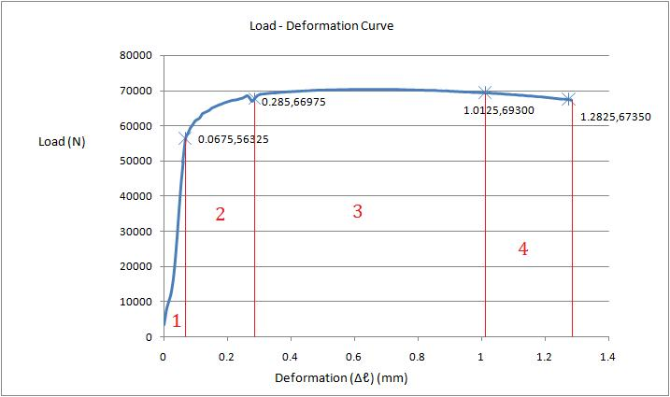
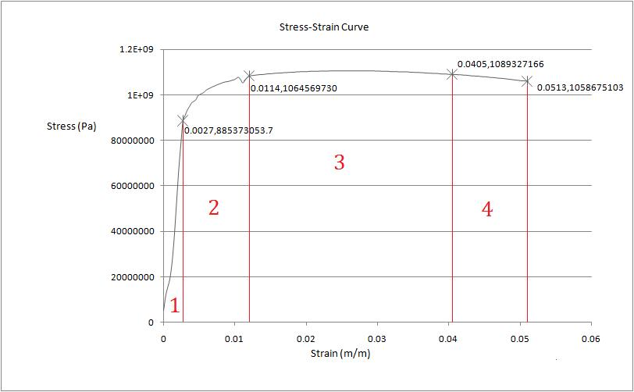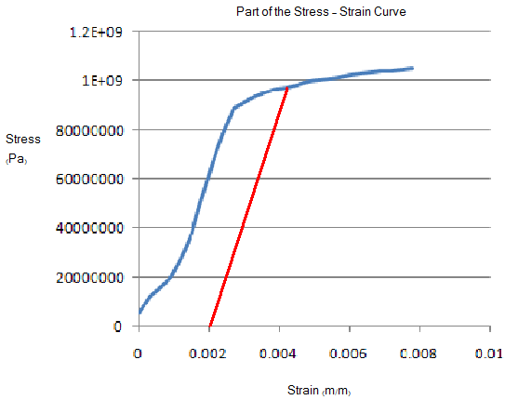

Extension mm | Force (N) | Strain (m/m) | Stress (Pa) | True Strain (m/m) | True Stress (Pa)
0 | 3375 | 0 | 53051647.69 | 0 | 53051647.69
0.0075 | 7575 | 0.0003 | 119071475.9 | 0.000299955 | 119107197.4
0.015 | 10050 | 0.0006 | 157976017.6 | 0.00059982 | 158070803.2
0.0225 | 12525 | 0.0009 | 196880559.2 | 0.000899595 | 197057751.7
0.03 | 17175 | 0.0012 | 269973940.5 | 0.001199281 | 270297909.2
0.0375 | 24300 | 0.0015 | 381971863.4 | 0.001498876 | 382544821.2
0.045 | 33300 | 0.0018 | 523442923.9 | 0.001798382 | 524385121.1
0.0525 | 42375 | 0.0021 | 666092909.9 | 0.002097798 | 667491705
0.06 | 49650 | 0.0024 | 780448683.8 | 0.002397125 | 782321760.6
0.0675 | 56325 | 0.0027 | 885373053.7 | 0.002696362 | 887763560.9
0.075 | 57825 | 0.003 | 908951563.8 | 0.002995509 | 911678418.5
0.0825 | 59325 | 0.0033 | 932530073.8 | 0.003294567 | 935607423.1
0.09 | 60300 | 0.0036 | 947856105.4 | 0.003593536 | 951268387.4
0.0975 | 61350 | 0.0039 | 964361062.5 | 0.003892415 | 968122070.6
0.105 | 61800 | 0.0042 | 971434615.5 | 0.004191205 | 975514640.9
0.1125 | 62250 | 0.0045 | 978508168.5 | 0.004489905 | 982911455.3
0.12 | 63375 | 0.0048 | 996192051.1 | 0.004788517 | 1000973773
0.1275 | 63750 | 0.0051 | 1002086679 | 0.005087039 | 1007197321
0.135 | 64050 | 0.0054 | 1006802381 | 0.005385472 | 1012239113
0.1425 | 64425 | 0.0057 | 1012697008 | 0.005683816 | 1018469381
0.15 | 65025 | 0.006 | 1022128412 | 0.005982072 | 1028261183
0.1575 | 65325 | 0.0063 | 1026844114 | 0.006280238 | 1033313232
0.165 | 65625 | 0.0066 | 1031559816 | 0.006578315 | 1038368111
0.1725 | 65925 | 0.0069 | 1036275518 | 0.006876304 | 1043425819
0.18 | 66150 | 0.0072 | 1039812295 | 0.007174204 | 1047298943
0.1875 | 66450 | 0.0075 | 1044527997 | 0.007472015 | 1052361957
0.195 | 66675 | 0.0078 | 1048064773 | 0.007769737 | 1056239678
0.2025 | 66900 | 0.0081 | 1051601550 | 0.008067371 | 1060119522
0.21 | 67125 | 0.0084 | 1055138326 | 0.008364916 | 1064001488
0.2175 | 67275 | 0.0087 | 1057496177 | 0.008662373 | 1066696394
0.225 | 67350 | 0.009 | 1058675103 | 0.008959741 | 1068203179
0.2325 | 67500 | 0.0093 | 1061032954 | 0.009257021 | 1070900560
0.24 | 67725 | 0.0096 | 1064569730 | 0.009554213 | 1074789600
0.2475 | 67875 | 0.0099 | 1066927581 | 0.009851316 | 1077490164
0.255 | 68250 | 0.0102 | 1072822209 | 0.010148331 | 1083764995
0.2625 | 68550 | 0.0105 | 1077537911 | 0.010445258 | 1088852059
0.27 | 67800 | 0.0108 | 1065748656 | 0.010742097 | 1077258741
0.2775 | 66975 | 0.0111 | 1052780475 | 0.011038847 | 1064466339
0.285 | 67725 | 0.0114 | 1064569730 | 0.01133551 | 1076705825
0.2925 | 68475 | 0.0117 | 1076358985 | 0.011632084 | 1088952385
0.3 | 68850 | 0.012 | 1082253613 | 0.011928571 | 1095240656
0.3075 | 69000 | 0.0123 | 1084611464 | 0.01222497 | 1097952185
0.315 | 69075 | 0.0126 | 1085790389 | 0.012521281 | 1099471348
0.3225 | 69150 | 0.0129 | 1086969315 | 0.012817504 | 1100991219
0.33 | 69225 | 0.0132 | 1088148240 | 0.013113639 | 1102511797
0.3375 | 69300 | 0.0135 | 1089327166 | 0.013409687 | 1104033083
0.345 | 69300 | 0.0138 | 1089327166 | 0.013705647 | 1104359881
0.3525 | 69375 | 0.0141 | 1090506091 | 0.01400152 | 1105882227
0.36 | 69450 | 0.0144 | 1091685017 | 0.014297305 | 1107405281
0.3675 | 69525 | 0.0147 | 1092863942 | 0.014593002 | 1108929042
0.375 | 69525 | 0.015 | 1092863942 | 0.014888612 | 1109256902
0.3825 | 69600 | 0.0153 | 1094042868 | 0.015184135 | 1110781724
0.39 | 69675 | 0.0156 | 1095221793 | 0.015479571 | 1112307253
0.3975 | 69675 | 0.0159 | 1095221793 | 0.015774919 | 1112635820
0.405 | 69750 | 0.0162 | 1096400719 | 0.01607018 | 1114162411
0.4125 | 69750 | 0.0165 | 1096400719 | 0.016365354 | 1114491331
0.42 | 69825 | 0.0168 | 1097579644 | 0.016660441 | 1116018982
0.4275 | 69825 | 0.0171 | 1097579644 | 0.016955441 | 1116348256
0.435 | 69900 | 0.0174 | 1098758570 | 0.017250353 | 1117876969
0.4425 | 69900 | 0.0177 | 1098758570 | 0.017545179 | 1118206597
0.45 | 69975 | 0.018 | 1099937495 | 0.017839918 | 1119736370
0.4575 | 69975 | 0.0183 | 1099937495 | 0.01813457 | 1120066352
0.465 | 70050 | 0.0186 | 1101116421 | 0.018429135 | 1121597186
0.4725 | 70050 | 0.0189 | 1101116421 | 0.018723614 | 1121927521
0.48 | 70125 | 0.0192 | 1102295346 | 0.019018006 | 1123459417
0.4875 | 70125 | 0.0195 | 1102295346 | 0.019312311 | 1123790106
0.495 | 70125 | 0.0198 | 1102295346 | 0.01960653 | 1124120794
0.5025 | 70125 | 0.0201 | 1102295346 | 0.019900662 | 1124451483
0.51 | 70200 | 0.0204 | 1103474272 | 0.020194707 | 1125985147
0.5175 | 70200 | 0.0207 | 1103474272 | 0.020488666 | 1126316189
0.525 | 70200 | 0.021 | 1103474272 | 0.020782539 | 1126647232
0.5325 | 70200 | 0.0213 | 1103474272 | 0.021076326 | 1126978274
0.54 | 70200 | 0.0216 | 1103474272 | 0.021370026 | 1127309316
0.5475 | 70275 | 0.0219 | 1104653197 | 0.02166364 | 1128845102
0.555 | 70275 | 0.0222 | 1104653197 | 0.021957167 | 1129176498
0.5625 | 70275 | 0.0225 | 1104653197 | 0.022250609 | 1129507894
0.57 | 70275 | 0.0228 | 1104653197 | 0.022543964 | 1129839290
0.5775 | 70275 | 0.0231 | 1104653197 | 0.022837234 | 1130170686
0.585 | 70350 | 0.0234 | 1105832123 | 0.023130417 | 1131708595
0.5925 | 70350 | 0.0237 | 1105832123 | 0.023423515 | 1132040344
0.6 | 70350 | 0.024 | 1105832123 | 0.023716527 | 1132372094
0.6075 | 70350 | 0.0243 | 1105832123 | 0.024009452 | 1132703844
0.615 | 70350 | 0.0246 | 1105832123 | 0.024302293 | 1133035593
0.6225 | 70350 | 0.0249 | 1105832123 | 0.024595047 | 1133367343
0.63 | 70350 | 0.0252 | 1105832123 | 0.024887716 | 1133699092
0.6375 | 70350 | 0.0255 | 1105832123 | 0.025180299 | 1134030842
0.645 | 70350 | 0.0258 | 1105832123 | 0.025472796 | 1134362592
0.6525 | 70350 | 0.0261 | 1105832123 | 0.025765208 | 1134694341
0.66 | 70350 | 0.0264 | 1105832123 | 0.026057534 | 1135026091
0.6675 | 70350 | 0.0267 | 1105832123 | 0.026349775 | 1135357841
0.675 | 70350 | 0.027 | 1105832123 | 0.026641931 | 1135689590
0.6825 | 70350 | 0.0273 | 1105832123 | 0.026934001 | 1136021340
0.69 | 70350 | 0.0276 | 1105832123 | 0.027225986 | 1136353090
0.6975 | 70350 | 0.0279 | 1105832123 | 0.027517886 | 1136684839
0.705 | 70350 | 0.0282 | 1105832123 | 0.027809701 | 1137016589
0.7125 | 70350 | 0.0285 | 1105832123 | 0.02810143 | 1137348338
0.72 | 70350 | 0.0288 | 1105832123 | 0.028393075 | 1137680088
0.7275 | 70350 | 0.0291 | 1105832123 | 0.028684634 | 1138011838
0.735 | 70350 | 0.0294 | 1105832123 | 0.028976108 | 1138343587
0.7425 | 70275 | 0.0297 | 1104653197 | 0.029267498 | 1137461397
0.75 | 70275 | 0.03 | 1104653197 | 0.029558802 | 1137792793
0.7575 | 70275 | 0.0303 | 1104653197 | 0.029850022 | 1138124189
0.765 | 70200 | 0.0306 | 1103474272 | 0.030141157 | 1137240585
0.7725 | 70200 | 0.0309 | 1103474272 | 0.030432207 | 1137571627
0.78 | 70200 | 0.0312 | 1103474272 | 0.030723173 | 1137902669
0.7875 | 70200 | 0.0315 | 1103474272 | 0.031014054 | 1138233712
0.795 | 70125 | 0.0318 | 1102295346 | 0.03130485 | 1137348338
0.8025 | 70125 | 0.0321 | 1102295346 | 0.031595562 | 1137679027
0.81 | 70125 | 0.0324 | 1102295346 | 0.031886189 | 1138009716
0.8175 | 70125 | 0.0327 | 1102295346 | 0.032176732 | 1138340404
0.825 | 70050 | 0.033 | 1101116421 | 0.03246719 | 1137453263
0.8325 | 70050 | 0.0333 | 1101116421 | 0.032757564 | 1137783598
0.84 | 70050 | 0.0336 | 1101116421 | 0.033047854 | 1138113933
0.8475 | 70050 | 0.0339 | 1101116421 | 0.03333806 | 1138444268
0.855 | 70050 | 0.0342 | 1101116421 | 0.033628181 | 1138774603
0.8625 | 69975 | 0.0345 | 1099937495 | 0.033918218 | 1137885339
0.87 | 69975 | 0.0348 | 1099937495 | 0.034208171 | 1138215320
0.8775 | 69900 | 0.0351 | 1098758570 | 0.03449804 | 1137324996
0.885 | 69900 | 0.0354 | 1098758570 | 0.034787825 | 1137654623
0.8925 | 69900 | 0.0357 | 1098758570 | 0.035077527 | 1137984251
0.9 | 69825 | 0.036 | 1097579644 | 0.035367144 | 1137092512
0.9075 | 69825 | 0.0363 | 1097579644 | 0.035656677 | 1137421786
0.915 | 69750 | 0.0366 | 1096400719 | 0.035946127 | 1136528985
0.9225 | 69750 | 0.0369 | 1096400719 | 0.036235493 | 1136857905
0.93 | 69675 | 0.0372 | 1095221793 | 0.036524775 | 1135964044
0.9375 | 69675 | 0.0375 | 1095221793 | 0.036813973 | 1136292611
0.945 | 69600 | 0.0378 | 1094042868 | 0.037103088 | 1135397688
0.9525 | 69600 | 0.0381 | 1094042868 | 0.037392119 | 1135725901
0.96 | 69600 | 0.0384 | 1094042868 | 0.037681067 | 1136054114
0.9675 | 69525 | 0.0387 | 1092863942 | 0.037969931 | 1135157777
0.975 | 69450 | 0.039 | 1091685017 | 0.038258712 | 1134260733
0.9825 | 69450 | 0.0393 | 1091685017 | 0.03854741 | 1134588238
0.99 | 69450 | 0.0396 | 1091685017 | 0.038836024 | 1134915744
0.9975 | 69375 | 0.0399 | 1090506091 | 0.039124555 | 1134017284
1.005 | 69375 | 0.0402 | 1090506091 | 0.039413002 | 1134344436
1.0125 | 69300 | 0.0405 | 1089327166 | 0.039701367 | 1133444916
1.02 | 69300 | 0.0408 | 1089327166 | 0.039989648 | 1133771714
1.0275 | 69300 | 0.0411 | 1089327166 | 0.040277846 | 1134098512
1.035 | 69225 | 0.0414 | 1088148240 | 0.040565962 | 1133197578
1.0425 | 69225 | 0.0417 | 1088148240 | 0.040853994 | 1133524022
1.05 | 69150 | 0.042 | 1086969315 | 0.041141943 | 1132622026
1.0575 | 69150 | 0.0423 | 1086969315 | 0.04142981 | 1132948117
1.065 | 69075 | 0.0426 | 1085790389 | 0.041717593 | 1132045060
1.0725 | 69000 | 0.0429 | 1084611464 | 0.042005294 | 1131141296
1.08 | 68925 | 0.0432 | 1083432538 | 0.042292912 | 1130236824
1.0875 | 68925 | 0.0435 | 1083432538 | 0.042580448 | 1130561854
1.095 | 68850 | 0.0438 | 1082253613 | 0.0428679 | 1129656321
1.1025 | 68850 | 0.0441 | 1082253613 | 0.04315527 | 1129980997
1.11 | 68775 | 0.0444 | 1081074687 | 0.043442558 | 1129074403
1.1175 | 68700 | 0.0447 | 1079895762 | 0.043729763 | 1128167102
1.125 | 68700 | 0.045 | 1079895762 | 0.044016885 | 1128491071
1.1325 | 68625 | 0.0453 | 1078716836 | 0.044303926 | 1127582709
1.14 | 68550 | 0.0456 | 1077537911 | 0.044590883 | 1126673640
1.1475 | 68475 | 0.0459 | 1076358985 | 0.044877759 | 1125763863
1.155 | 68475 | 0.0462 | 1076358985 | 0.045164552 | 1126086770
1.1625 | 68400 | 0.0465 | 1075180060 | 0.045451263 | 1125175933
1.17 | 68325 | 0.0468 | 1074001134 | 0.045737892 | 1124264387
1.1775 | 68250 | 0.0471 | 1072822209 | 0.046024438 | 1123352135
1.185 | 68250 | 0.0474 | 1072822209 | 0.046310903 | 1123673982
1.1925 | 68175 | 0.0477 | 1071643283 | 0.046597285 | 1122760668
1.2 | 68100 | 0.048 | 1070464358 | 0.046883586 | 1121846647
1.2075 | 68025 | 0.0483 | 1069285432 | 0.047169804 | 1120931919
1.215 | 67950 | 0.0486 | 1068106507 | 0.047455941 | 1120016483
1.2225 | 67875 | 0.0489 | 1066927581 | 0.047741996 | 1119100340
1.23 | 67800 | 0.0492 | 1065748656 | 0.048027969 | 1118183490
1.2375 | 67725 | 0.0495 | 1064569730 | 0.04831386 | 1117265932
1.245 | 67650 | 0.0498 | 1063390805 | 0.04859967 | 1116347667
1.2525 | 67575 | 0.0501 | 1062211879 | 0.048885398 | 1115428694
1.26 | 67575 | 0.0504 | 1062211879 | 0.049171044 | 1115747358
1.2675 | 67500 | 0.0507 | 1061032954 | 0.049456609 | 1114827325
1.275 | 67425 | 0.051 | 1059854028 | 0.049742092 | 1113906584
1.2825 | 67350 | 0.0513 | 1058675103 | 0.050027494 | 1112985136

Dimension | Value (mm)
A-length of narrow section | 80
D-Diameter | 9
C-Outer Diameter | 18
R-Radius of fillet | 2
L-length overall | 200
G-Gage length | 25
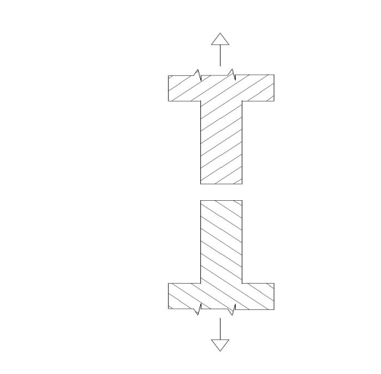

References:
- Slides provided on Moodle.
- Textbook: Materials Science and Engineering: An Introduction, by W.D. Callister, 7th Ed., Wiley.

